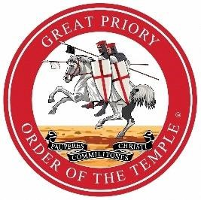

Chancery of the Orders Mark Masons’ Hall 86 St James’s Street, London, SW1A 1PL

23 June 2021

**To: All Brother Knights of the Province of Cheshire and North Wales**

Dear Sir and Brother Knight

**Appointment of Provincial Prior**

Following the recent passing of R.E.Kt. Dr Anthony Mathie, who had been your Provincial Prior for almost eight years, the Most Eminent & Supreme Grand Master has been considering the appointment of a successor.

I am delighted to inform you that V.E.Kt. Alan Pierce, *JP*, P.Gt.Reg. has accepted the Grand Master’s invitation to be the next Provincial Prior for Cheshire and North Wales and he will be installed into charge of the Province on Saturday, 16 October 2021.

V.E.Kt. Alan is well known to you all having first been appointed to Active Provincial Rank in 1994. Other Active Rank appointments followed thereafter culminating in his succession to the office of Sub-Prior in 2013 and his experience in that office will undoubtedly stand him in good stead in the future. I am sure you will join me in congratulating him on his preferment.

In making today’s announcement, it would be remiss of me if I did not take this opportunity to pay tribute to the contribution made by R.E.Kt. Tony during his term as your Provincial Prior. He was a very distinguished and experienced Freemason, possessing a keen sense of humour and an enviable ability to communicate easily and effectively with those around him. His contribution is well recorded, and his legacy was to cultivate a Province that is vibrant, forward-looking, and well placed to grow in the future.

Further information regarding the arrangements for the Installation meeting on 16 October 2021 will follow in due course.

Yours in the Bonds of the Order.

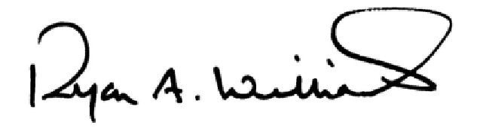

R.E.Kt. Ryan A. Williams, K.C.T.

Great Vice-Chancellor   
  
 020 7747 1168| r.williams@mmh.org.uk| markmasonshall.org